Evidence for the PDA in software development

P - Planning Unit

Benjamin Bowen - Cohort E17

P5

Create a user site map

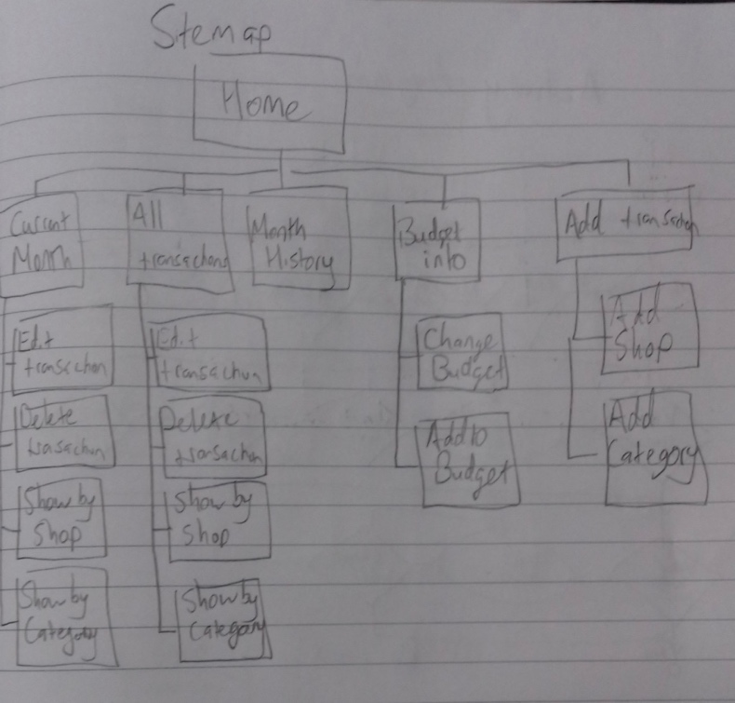

P6

Produce two wireframe designs

Wire frame diagram for my app’s homepage

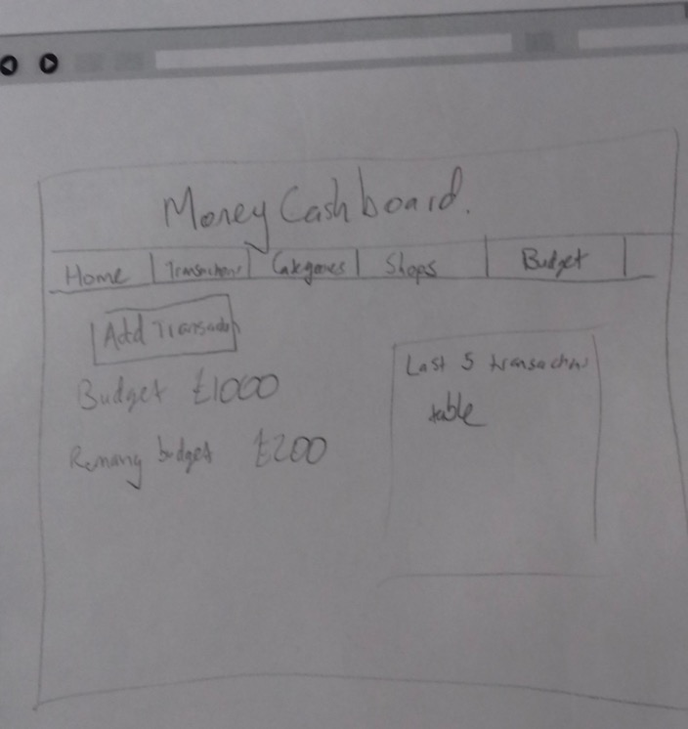

Wire frame diagram for the transactions page.

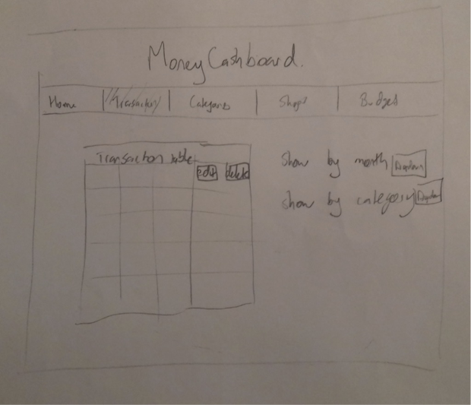

P10

Take a screenshot of an example of pseudocode for a function.

This is the pseudocode and java code for the move forward one step method of a robot. The robot is on a two dimensional (x,y) grid, and has an orientation, the direction it is facing, in addition to the initial position.



P 11

Take a screenshot of one of your projects where you have worked alone and attach the Github link.

This is a ruby, sinatra, sql, html and css project. I built a money tracking app:

<https://github.com/benjaminbowen00/ruby_sql_sinatra_project>

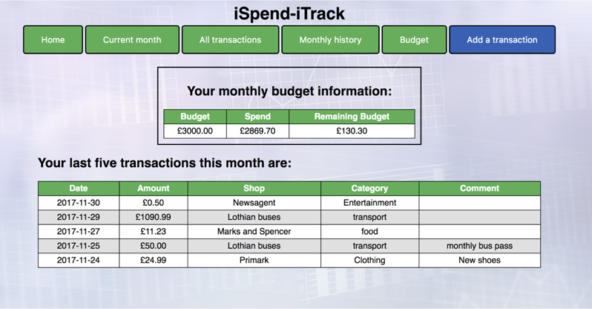

P 12

Take screenshots or photos of your planning and the different stages of development to show changes.

Class diagrams. Initially the date was saved only as string, but this was later changed to a DateMonth object so that only transactions from the last six months could be shown:

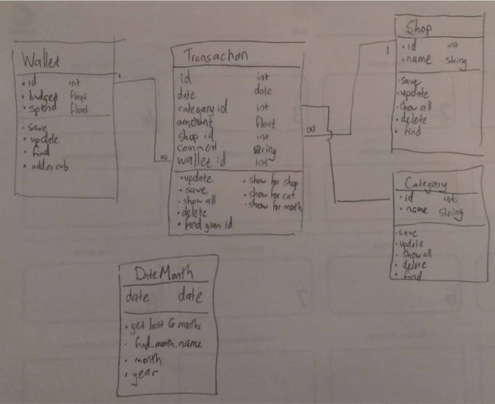

Planning the user needs for the app:

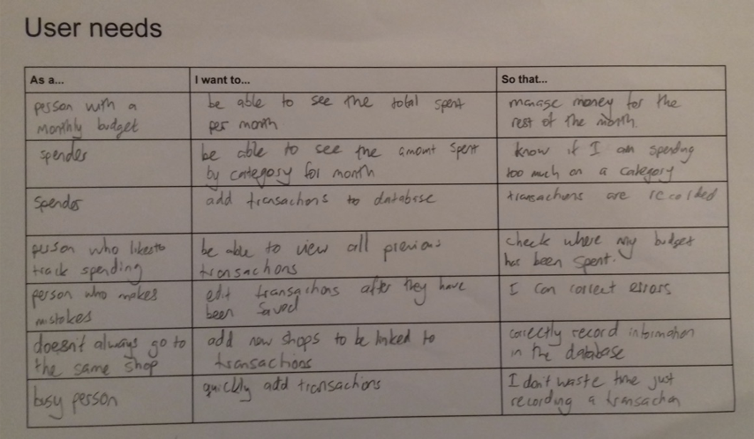

An example of a user journey from the planning of the project:

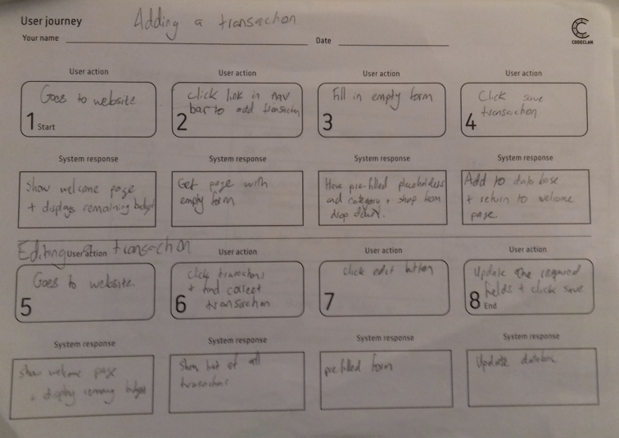

P13

Show user input being processed according to design requirements. Take a screenshot of:

* The user inputting something into your program
* The user input being saved or used in some way

The monthly budget was initially £1600:

The user inputs the new budget of £1500:

This new budget is then saved and displayed on the budget information page. The remaining budget is now £100 lower than before:

P14

Show an interaction with data persistence. Take a screenshot of:

* Data being inputted into your program
* Confirmation of the data being saved

A new transaction is added through completing the form which saves the record to the database:

This is then visible on the monthly transactions page:

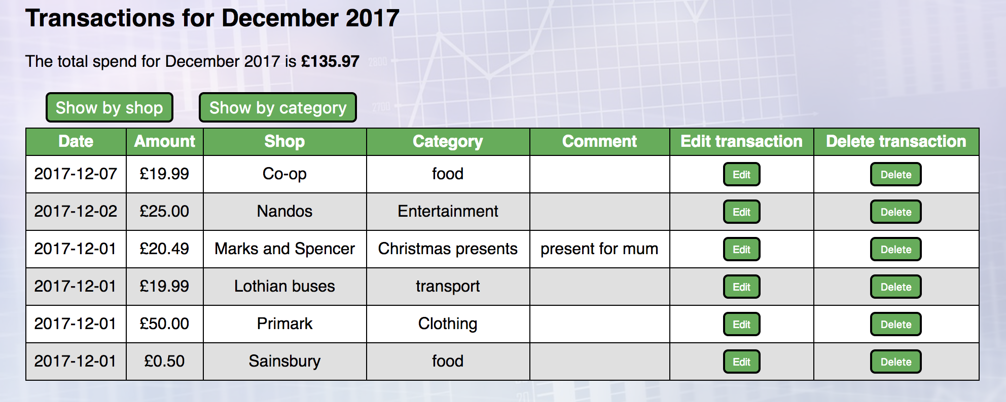

P15

Show the correct output of results and feedback to user. Take a screenshot of:

* The user requesting information or an action to be performed
* The user request being processed correctly and demonstrated in the program

The user selects to view the transactions for November 2017 - the button changes colour when the mouse hovers over it.



The page showing the transactions for November 2017 is returned:

